Brain Computer Interface Final Paper (Only hyungwon Part)

Hyungwon Yang

The Study of Human Visual Word Recognition:

EEG Application and Mask Paradigm.

**2. Response Time and Error Analysis**

**RL_result data**

Even thought the reference paper did not pay attention on this data (we may not be able to reveal the reason.), we have focused on this data so as to support the possible hypothesis that phonological cue will accelerate the semantic process in the visual word recognition. Therefore, RL data (right button responses for meaningful words and Left button responses for non-meaningful words.) has been collected from 6 subjects during EEG application. Figure 2. shows the RL_result data and it contains right or left button responses and response time from each subject. We have reorganized the data based on the 6 independent variables (11, 12, 13, 21, 22, and 23) by matlab and imported it to R in order to run analysis of variance and post hoc test.

RL_result Table

|  |  |
| --- | --- |
| Response | Time |
| R | 0.790864 |
| L | 0.657544 |
| L | 0.676448 |
| R | 0.594052 |
| L | 0.925795 |
| R | 0.789432 |
| L | 0.601096 |

Figure 2. RL_result data. First column shows right and left response

and second column shows response time from each subject.

**Response Time Result**

After applied EEG with 240 words to 6 subjects, we have obtained 1,440 response time values. Each independent variable was assigned with 240 response time values and these time values were measured by R. Due to a number of outliers that impair the mean values of the each independent variable, we use median value instead of the mean value. Figure 3. shows a boxplot that describes the median values of the each independent variable (horizontal lines mark median values). Horizontal axis shows the independent variables and vertical axis shows the response time from 0.5 to 0.9 seconds (we reject the time values that below and above from the Figure 3. in order to remove outliers from the table). In order to find significant differences among the variables, we run analysis of variance and tukey’s HSD. When it comes to anova test, we find significant differences among the variables, *F*(5,1434) = 3.419, P < 0.005. Furthermore, tukey’s HSD shows significant differences between full repetition (same words) and partial repetition (phonological similar words), p < 0.05 and between full repetition and unrelated repetition (orthographical different words), p < 0.05. However, we cannot see the large difference between partial repetition and unrelated repetition, p > 0.05.

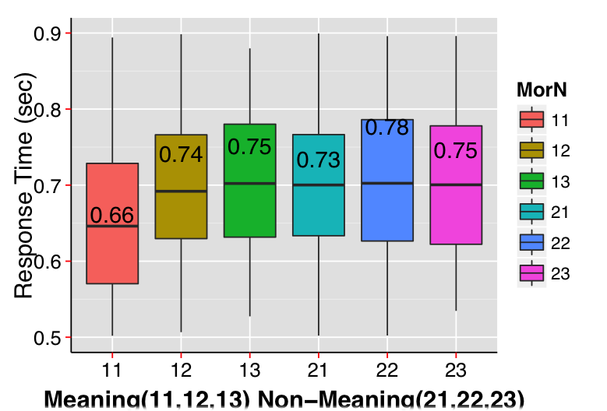

Figure 3. This boxplot shows the median values from each independent variable. Median response time values have been written in the box and outliers have been discarded.

Phonological facilitatory effect that helps semantic process in visual word recognition has been supported from many research papers. Ludovic Ferrand and Jonathan Grainger (2007) provides evidence that phonological similar masked words produced facilitatory effect in visual word recognition from masked paradigm test. If phonological cue accelerates the semantic process, response time should be reduced due to the phonological effect. As our test result provides in Figure 3, however, we did not derive the phonological boosting effects from the test results because response time of 12 has not been decreased compared to that of 13. Moreover, we have seen statistical analysis proven that there is no significant difference between 12 and 13 in response time values. Surprisingly, even our response time results in non-meaningful word variables (21,22 and 23) did not reveal any significant difference which further contrast another previous research paper (Charles A. Perfetti and Laura Bell, 1991) in which the authors found that pseudo-words were also influenced by phonological effect. Our findings reject the previous propositions, phonological facilitatory effects, and only confirm the mask effects by reduced meaningful full repetition (11).

**Response Error Rate**

Response error rate has been divided into 3 groups: Full-repetition, Partial-repetition, and Unrelated-repetition. In each group, meaningful and non-meaningful error rates are combined so as to compare between them more easily. Furthermore, error rate was transformed into response correctness rate that gets rid of ambiguousness. Thus, x-axis shows 3 groups and y-axis shows response correctness rate.

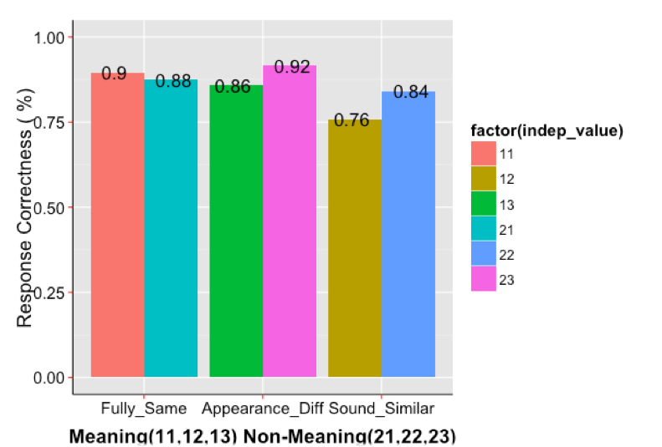

Figure 4. This barplot shows the response correctness rate. Horizontal axis consists of 3 groups: Fully_Same (Full-repetition), Appearance_Diff (Unrelated-repetition), and Sound_Similar (Partial-repetition). Vertical axis shows response correctness from 0% to 100%. Each group combines with meaningful and non-meaningful target word sets.

Although Figure 3. does not describe the phonological effect, we might be able to find the phonological process through Figure 4. Compared to the two groups (Full-repetition and Unrelated-repetition), Partial-repetition presents lower response correctness rate. This phenomenon proves phonological effect in semantic process in visual word recognition. Our conclusion is that phonological effect is not always supporting the semantic process; however, it also prevents the phonological effect from lubricating the semantic procedure because phonologically similar words might trigger confusion in the word recognition process as well.

**Reference**

Ferrand, L., & Grainger, J. (1992). Phonology and orthography in visual word recognition: Evidence

from masked non-word priming. *Quarterly Journal of Experimental Psychology: Section A*, *45*(3), 353-372.

Perfetti, C. A., & Bell, L. (1991). Phonemic activation during the first 40 ms of word identification:

Evidence from backward masking and priming. *Journal of Memory and Language*, *30*(4), 473-485.